**Project 1 : Exploring Weather Trends**

**Synopsis :**

This project is to analyze the Delhi's and global temperature data and compare the temperature trends for a century i.e from '1900' to'1999'.

**Tools and Techniques:**

This project uses the below tools

• SQL to extract the data.

• Excel to plot the chart.

• Moving average for a clean flow in the chart.

**Execution of the project:**

*Step 1:*

Below SQLs were used to extract the data from the tables. This extracts are downloaded as a CSV file.

|  |
| --- |
| * Select * from global_data where Year Between '1900' and '1999' * Select * from city_data where city='Delhi' and Year Between '1900' and '1999' |

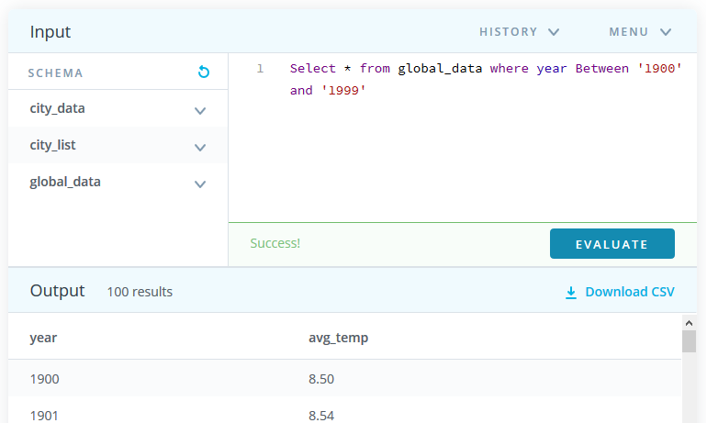

*Step 2:*

* Open and import both the data into a single excel sheet and bringing the common year and tabulating Delhi's and Globe's temperature alike below.

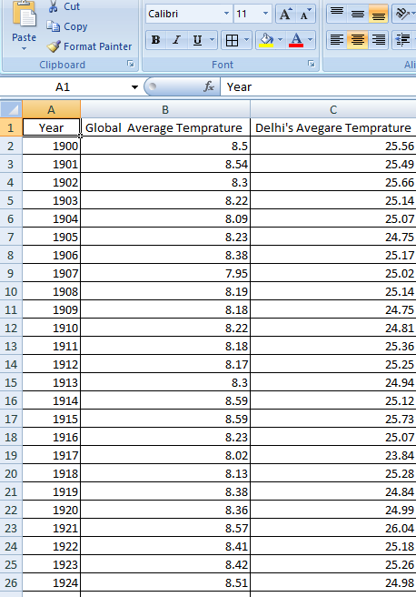

* After the date is collated then the moving average with interval of 4 years is calualated.The formula provided in the screen shot

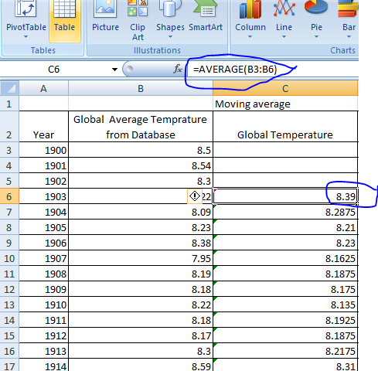

* Using the create line chart option (Insert -> Line) from menu bar, a chart is created with X-axis as year and y axis as temperature.
* Titles are added to the chart to make it informative and serve as a standalone reference.

**Observation on the weather trends:**

1. Delhi's temperature (avgas 24-25 Celsius) is very high compared to global temperature(avgas 8-9 Celsius).
2. Global average after during 1918 was the lowest and the temperature never went down to the lowest point again. Delhi's temperature dropped to lowest points 2-3 times.
3. In late 1980s the global temperature spiked steadily to reach 9 Celsius values and On other hand Delhi's temperature were around the same average.
4. Delhi measured an average temperature around 24-25 for the whole century.
5. Global Temperature flow is not as same the flow of Delhi's temperature, explaining Delhi has not been a serious contribute for the global temperature raise(global warming) in 20th century.